

ASSET VERIFICATION AND RECORDING TOOL KIT


Plot 31, Bukoto Street
P.O Box 7657, Kampala, Uganda
+256 (0) 39 2000216/0772525235
email: cpa@cpa.ug

www.cpa.com

August to September 2026

VERIFICATION DETAILS

NAME OF THE REGION: | WESTERN
SUB-REGION: | TOORO
Name of Local Government | KABAROLE
VERIFIER PARTICULARS
Full name | ZALWANGO MARIA, NASSEJJE NADIA, NABBOSA SUMAYA
Contact/ email and Telephone | 0751977570/ 0754884004/ 0708098456
Supervisor/ Sub team leader
Name | DEPAUL MBONIGABA
Contact | 0788483159
Date of submission

HEALTH CENTRES
INFORMANT INTERVIEW/DISCUSSION GUIDE (INCHARGE OR RESPONSIBLE PERSON JULIUS BAGYEMA)

Name of Health Centre: NYAKITOKOLI HEALTH CENTER III

1a | Does the Facility have a record of all assets provided under UgIFT.  (Obtain a record and verify if it has the costs and numbers supplied | Yes,
1b | If Not ask how many were supplied and when. | Delivered on 06/08/2024

2 | How does this facility Maintain (repair/service/replace) the assets provided under Ugift

Passing through regional referral officials

3 | Does the facility take regular record about functionality/ or breakdown of the assets provided? | Yes

4 | How has the UgIFT support helped in service delivery in the area, any issues, challenges and any recommendations for better program implementation.

It has provided space for the patients since new buildings are being set up.

Challenges
The glucometer is of a different type and they are done so getting another type is difficult in there are.
Some items like office chairs were brought faulty and lockable cupboards ,yet the local personels are not being able to repire them.
Recommendations

They recommend that they need more beds for male ward and female ward and also to provide the glucometer of a type that is easy to get.
They recommed that they need a visual set equiments

PROCEED TO VERIFICATION AFTER THIS DISCUSSION

Health centre checklist

NAME OF LG: KABAROLE DISTRICT NAME OF HEALTH FACILITY: IRUHURA HEALTH CENTRE III

Equipment/ Item | Department | Asset Number | Item  Description | Life in Months | Tag Number ( engrave no.) | Date Of Purchase | Date Placed In Service | Recoverable cost | Cost | Acc Dep Cost | Net Book Value | Ytd Deprn | Equipment status | Remarks
B.P. Machine, Digital
B.P. Machine (Aneroid wall mounted) | Health |  | Boxed |  |  |  | 6\8\2024 |  |  |  |  |  | Good condition | not in use still in store
Autoclave 20 Liters.,Duo Operated | Health |  | Silver in colour |  |  |  | 6/8/2024 |  |  |  |  |  | Good condition | 2 not in use
Bowl, Kick | Health |  | Silver |  |  |  | 6/8/2024 |  |  |  |  |  | Good condition | 1 not in use
Bowl Stand | Health |  | Silver |  |  |  | 6/8/2024 |  |  |  |  |  | Good condition | 2not in use
Counting chamber Neubauer- Improved | Health |  | Boxed |  |  |  | 6/8/2024 |  |  |  |  |  | Good condition | 2 received and still in store
Cupboard Steel, Lockable | Health |  | Steel and Grey in colour |  |  |  | 6/8/2024 |  |  |  |  |  | Good condition | 6Still in store 0ne faulty and 4 are in use
Drip Stand | Health |  | Have wheels and a metallic stand silver in colour |  |  |  | 6/8/2024 |  |  |  |  |  | Good condition | 7are still in use.
ESR Stand | Health |  | Boxed |  |  |  | 6/8/2024 |  |  |  |  |  | Good condition | 1 Still in store
Examination Couch | Health |  | Black mattresses with metallic stand |  |  |  | 6/8/2024 |  |  |  |  |  | Good condition | 4 are in use
Examination light,LED
Glucometer | Health |  | White in colour |  |  |  | 6/8/2024 |  |  |  |  |  | Good condition | 2 in use but the strips are done
Haemoglobin Meter, Digital
Height Meter | Health |  | White in colour |  |  |  | 6\8\2024 |  |  |  |  |  | Good condition | 2 are in use
Instrument Trolley | Health |  | Metallic and silver with wheels |  |  |  | 6/8/2024 |  |  |  |  |  | Good condition | 2 are in use
Microscope Binocular
Otoscope | Health |  | Boxed |  |  |  | 6/8/2024 |  |  |  |  |  | Good condition | 1 not yet used
Patient Screen | Health |  | Blue in colour |  |  |  | 6/8/2024 |  |  |  |  |  | Good condition | 4 not in use
Patient Trolley
Refrigerator, Basic | Health |  | White in colour |  |  |  | 6/8/2024 |  |  |  |  |  | Good condition | 2 in use
Stethoscope | Health |  | Boxed |  |  |  | 6/8/2024 |  |  |  |  |  | Good condition | 8 are still in store
Stop Watch | Health |  | Boxed |  |  |  | 6/8/2024 |  |  |  |  |  | Good condition | 1 still in store
Stretcher | Health |  | White in colour with wheels |  |  |  | 6/8/2024 |  |  |  |  |  | Good condition | 1 not in use and verified
Stove, Gas | Health |  | Boxed |  |  |  | 6/8/2024 |  |  |  |  |  | Good condition | 2 not in use.
Weighing Scale with Height Meter, Adult
Weighing Scale, Infant | Health |  | White in colour |  |  |  | 6/8/2024 |  |  |  |  |  | Good condition | 2 Still in store
Weighing Scale, Toddler | Health |  | White in color |  |  |  | 6\8\2024 |  |  |  |  |  | Good condition | Its in use and its one verified
Wheel Chair | Health |  | Black with wheels |  |  |  | 8/8/2024 |  |  |  |  |  | Good condition | 4 Not in use
Audio Visual Equipment
Medical Waste Bin | Health |  | Silver in color |  |  |  | 6/8/2024 |  |  |  |  |  | Good condition | 9 are in use
Wall Clock | Health |  | White in color |  |  |  | 6/8/2024 |  |  |  |  |  | One got broken. Others are in good condition | 4 still in store.
Diagnostic Equipment Set for MCH | Health |  | Boxed |  |  |  | 6/8/2024 |  |  |  |  |  | Good condition | 2 still in store
Diagnostic Equipment Set for OPD
Glassware Set, Laboratory, Basic | Health |  | Boxed |  |  |  | 6/8/2024 |  |  |  |  |  | Good condition | 2 still in store
Hollow Ware Set, Treatment | Health |  | Boxed |  |  |  | 6/8/2024 |  |  |  |  |  | Good condition | 2 still in health
Instrument Set, Dressing | Health |  | Boxed |  |  |  | 6/8/2024 |  |  |  |  |  | Good condition | 2 still in store
Instrument Set, Basic ENT
Instrument Set, Suture | Health |  | Boxed |  |  |  | 6\8\2024 |  |  |  |  |  | Good conditi0n | They received 3 and are still in store
Pulse Oximeter, Hand held | Health |  | White in colour |  |  |  | 6/8/2024 |  |  |  |  |  | Good condition | 2 and are still in store
Bed, Adult Patient with Mattress
Bed, Pediatric Patient, With Mattress | Health |  | Black mattresses |  |  |  | 6/8/2024 |  |  |  |  |  | Good condition | 4 not in use
Bedside Locker | Health |  | Grey in colour |  |  |  |  |  |  |  |  |  | Good condition | Some are in use and others in store.
Cupboard, Instrument | Health |  | White in color with glasses |  |  |  | 6\8\2024 |  |  |  |  |  | Good condition | Its in use
Delivery Bed, Hydraulic Manual
Oxygen Therapy Apparatus, Mininum 45L cylinder | Health |  | Boxed |  |  |  | 6/8/2024 |  |  |  |  |  | Good condition | 2 still in store
Resuscitator Manual, Infant, with all Mask sizes | Health |  | Boxed |  |  |  | 6/8/2024 |  |  |  |  |  | Good condition | 1 still in store
Resuscitator Manual, Adult, with all mask sizes | Health |  | Boxed |  |  |  | 6/8/2024 |  |  |  |  |  | Good condition | 1 still in store
Suction Apparatus, (Electric) | Health |  | White in colour |  |  |  |  |  |  |  |  |  | Good condition | 1 Not in use
Nebulizer, Ultrasonic | Health |  | Boxed |  |  |  | 6/8/2024 |  |  |  |  |  | Good condition | They received the electric one  1 still in store.
Oxygen Concentrator, Duo Flow | Health |  | White in colour with oxygen tubes |  |  |  | 6/8/2024 |  |  |  |  |  | Good condition | 1 Not in use
Bench | Health |  | Brown in colour |  |  |  | 6/8/2024 |  |  |  |  |  | Good condition | 4 in use
Disinfection Buckets | Health |  | White in colour |  |  |  | 6/8/2024 |  |  |  |  |  | Good condition | 6 still in store
Baby Cot | Health |  | Glassy with black mattresses |  |  |  | 6/8/2024 |  |  |  |  |  | Good condition | 2 not yet used.
Diagnostic Equipment Set for Ward | Health |  | Boxed |  |  |  | 6/8/2024 |  |  |  |  |  | Good condition | 2 still in store
Hollow Ware Set, Ward | Health |  | Boxed |  |  |  | 6/8/2024 |  |  |  |  |  | Good condition | 2 still in store
Instrument Set, Delivery | Health |  | Boxed |  |  | 6/8/2024 |  |  |  |  |  |  | Good condition | 2 still in store
Instrument Set, Stitch Removing | Health |  | Boxed |  |  | 6/8/2024 |  |  |  |  |  |  | Good condition | 3 still in store
MVA Kit | Health |  | Boxed |  |  | 6/8/2024 |  |  |  |  |  |  | Good condition | 5 still in store
Stool, Laboratory | Health |  | Black in color with wheels |  |  | 6\8\2024 |  |  |  |  |  |  | Good Condition | They are in use
Penguin Sucker | Health |  | Boxed |  |  | 6/8/2024 |  |  |  |  |  |  | Good condition | 3 still in store
Fetoscope, Dopplar | Health |  | Boxed |  |  | 6/8/2024 |  |  |  |  |  |  | Good condition | 2 still in store
Bubble CPAP
Centrifuge (Electric) | Health |  | White in colour |  |  | 6/8/2024 |  |  |  |  |  |  | Good condition | 1 still in store
Kangaroo Mother Care Chair | Health |  | Green in colour |  |  | 6/8/2024 |  |  |  |  |  |  | Good condition | 1 still in store
Radiant Infant Warmer
Haemoglobin Meter, Sahli | Health |  | Boxed |  |  | 6/8/2024 |  |  |  |  |  |  | Good condition | 1 still in store
Delivery Bed | Health |  | Black in color |  |  | 6\82024 |  |  |  |  |  |  | Good condition | Its in use
Examination light | Health |  | Black in colour with light glasses with wheels |  |  | 6/8/2024 |  |  |  |  |  |  | Good condition | 4 Still in store
Instrument set, ENT Basic for HCIII | Health |  | Boxed |  |  | 6/8/2024 |  |  |  |  |  |  | Good condition | 1 still in store
Bag Valve mask (Ambu Bag), Neonatal
Incubator
Office Chair | Health |  | Black in colour with soft seats and wheels |  |  | 6/8/2024 |  |  |  |  |  |  | Good condition 2 are faulty | 4 still in store
Desk | Healh |  | Brown and wooden |  |  | 6/8/2024 |  |  |  |  |  |  | Good condition | 4 are in use
Filing Cabinet | Health |  | Grey in colour with blue, green, orange lockers |  |  | 6/8/2024 |  |  |  |  |  |  | Good condition | 0ne faulty and the four are in use
Non Residential Buildings | Health |  | Painted orange and white |  |  | 6/8/2024 |  |  |  |  |  |  | Good condition | They are 3 and they are in use
Residential Buildings | Health |  | Painted orange and cream |  |  | 8/8/2024 |  |  |  |  |  |  | Good condition | They are 2 and they are in use

Refrigerator disinfection bucket Auto clave Items still in store
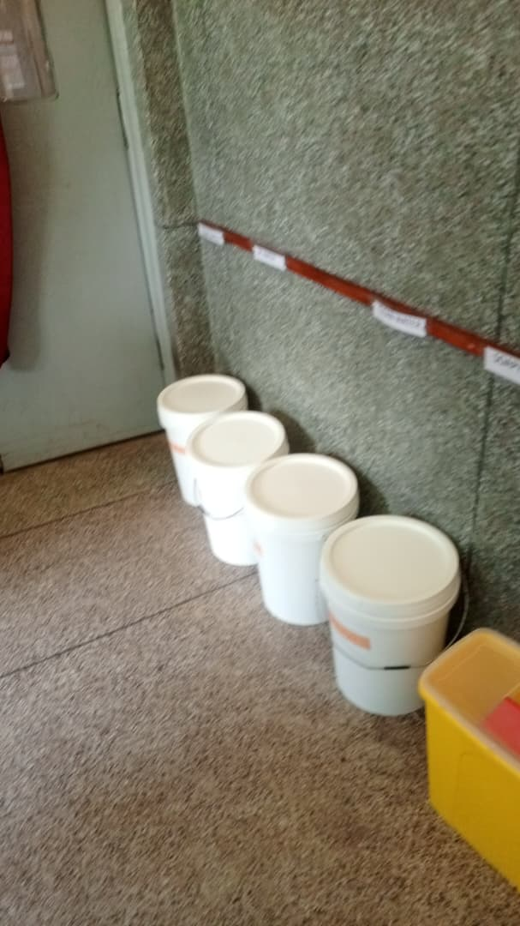
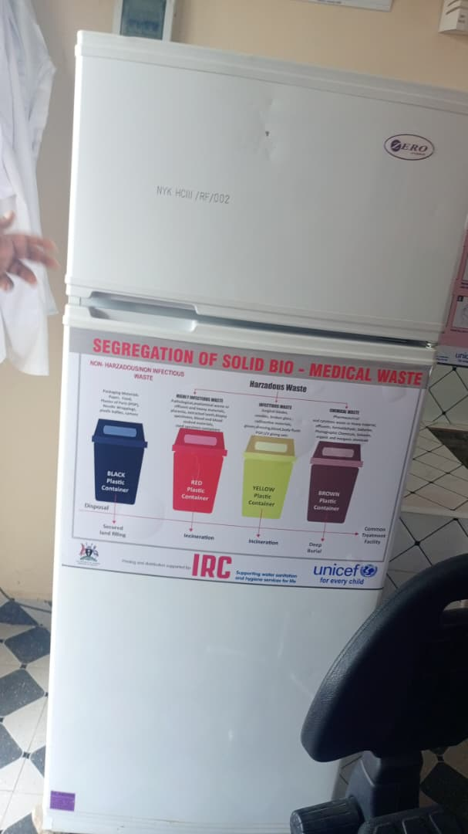
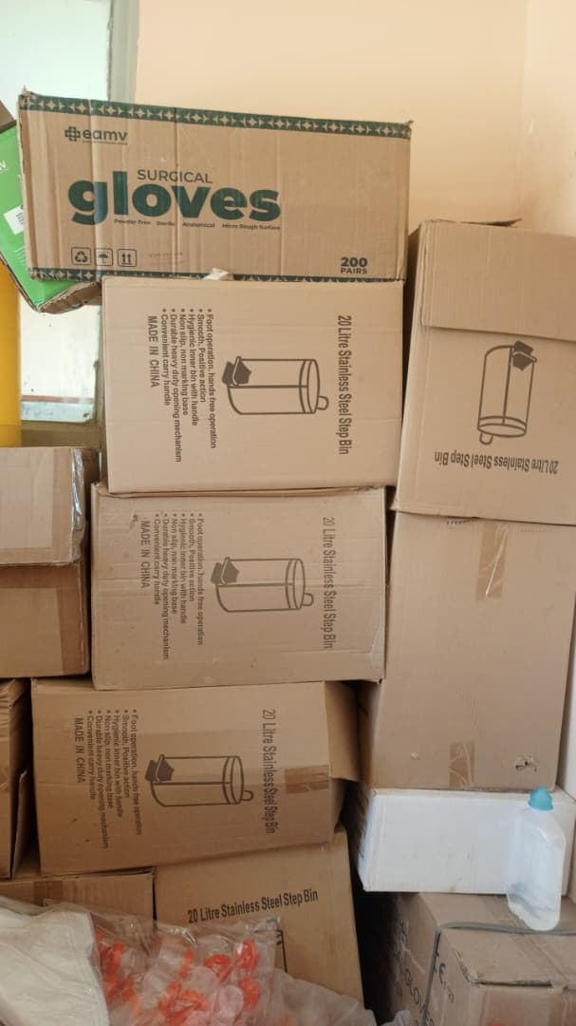
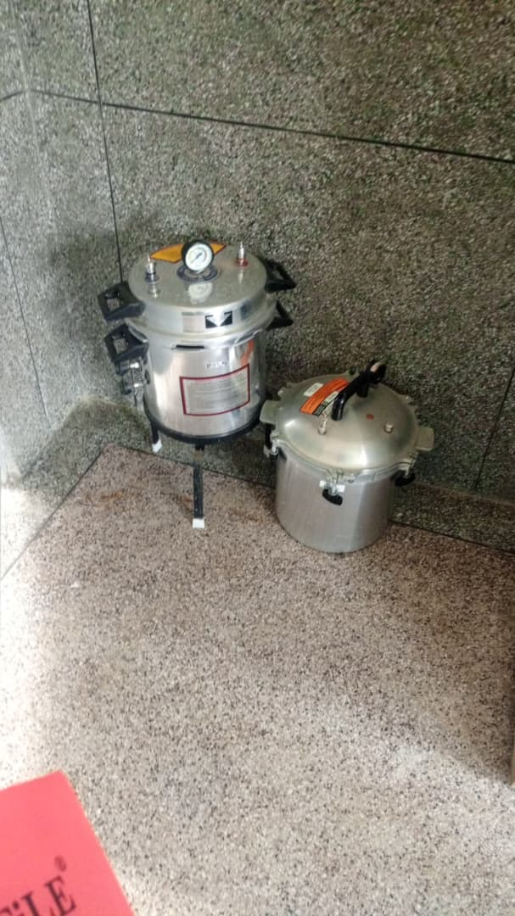

kangaroo chair Pit latrine faulty chair Pit latrine
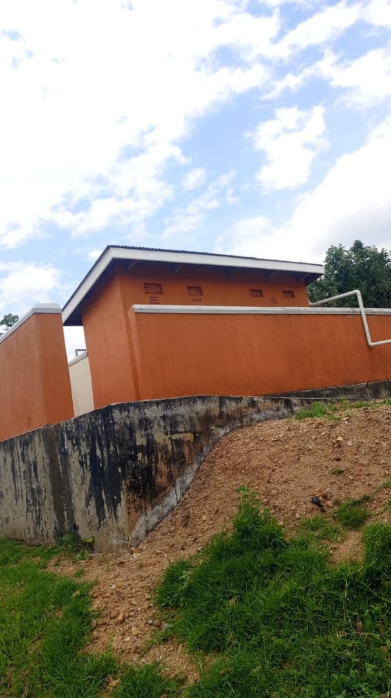
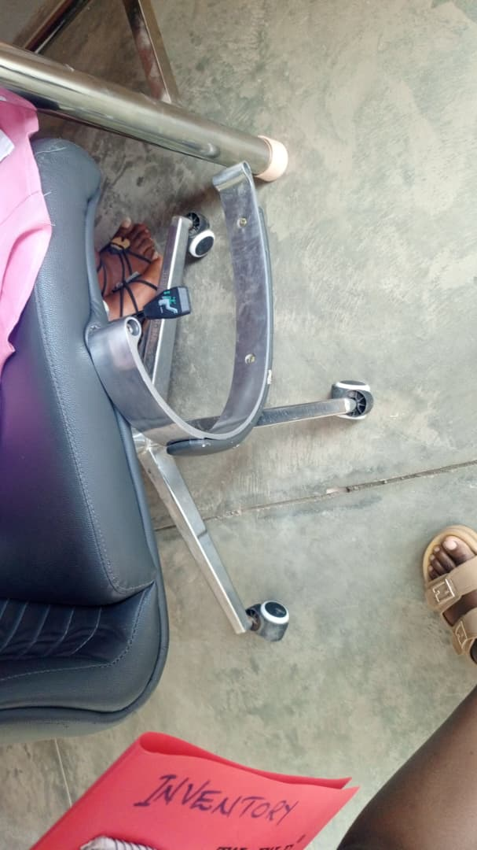
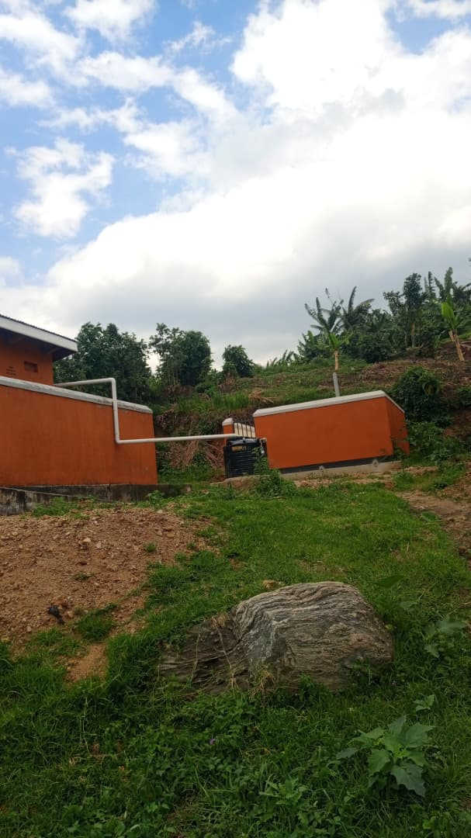
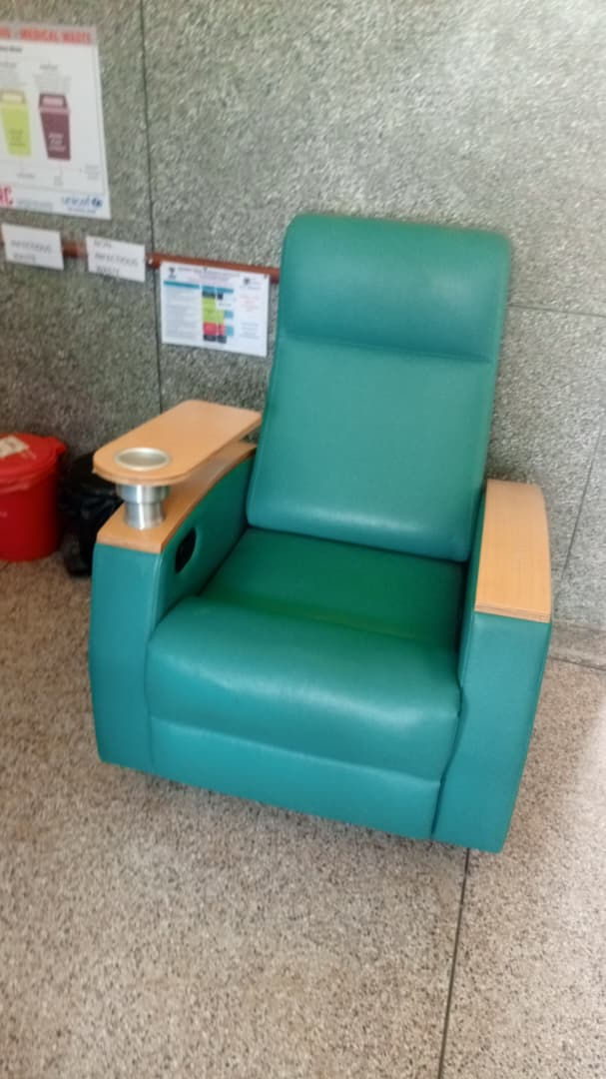

Sydraulic delivery bed Cupboard Sunction machine Items still in boxes
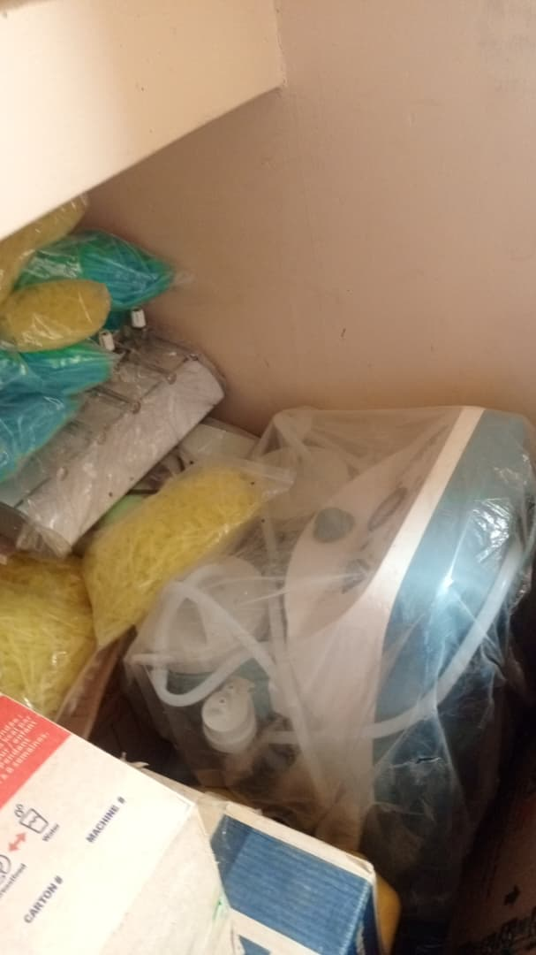
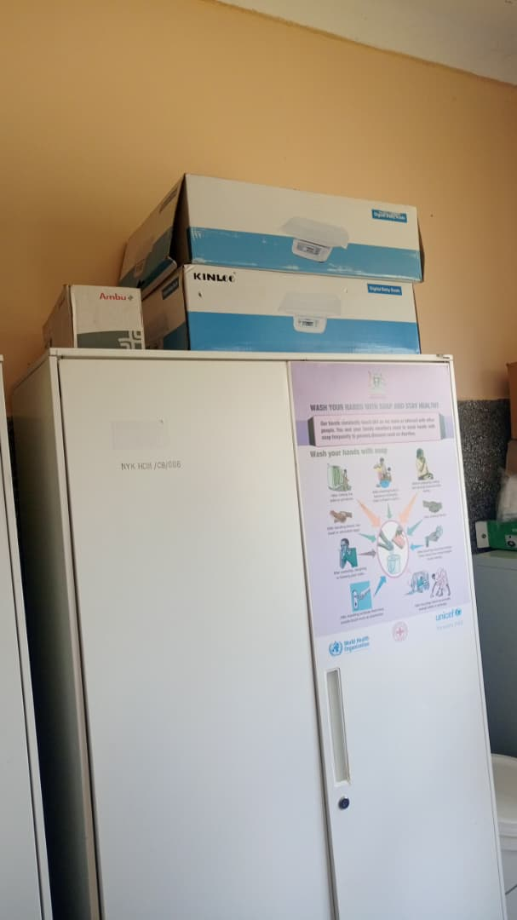
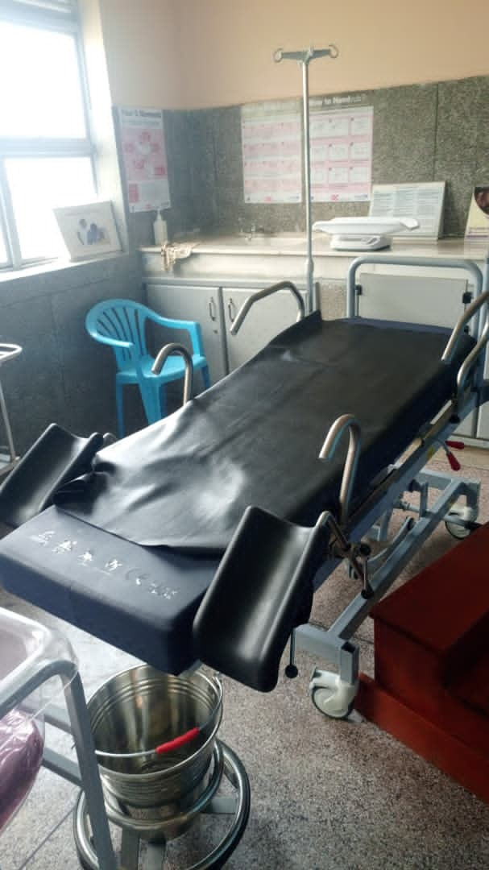
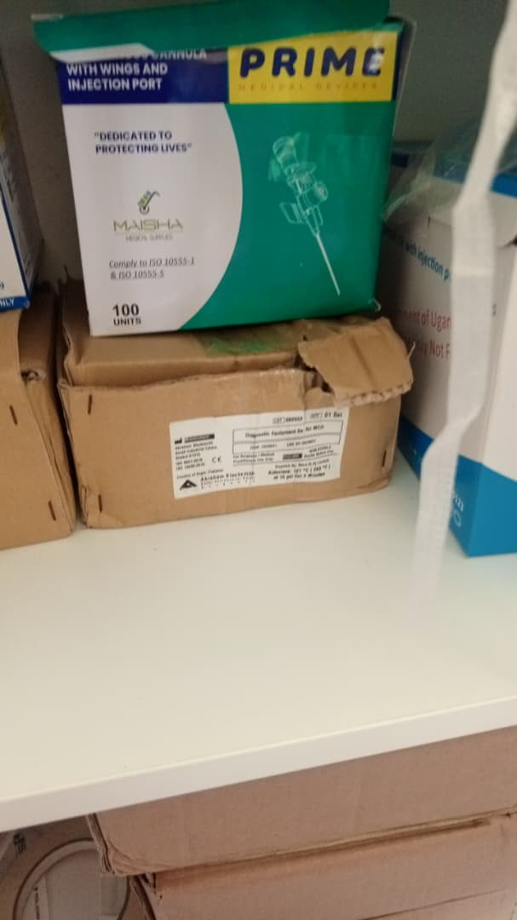

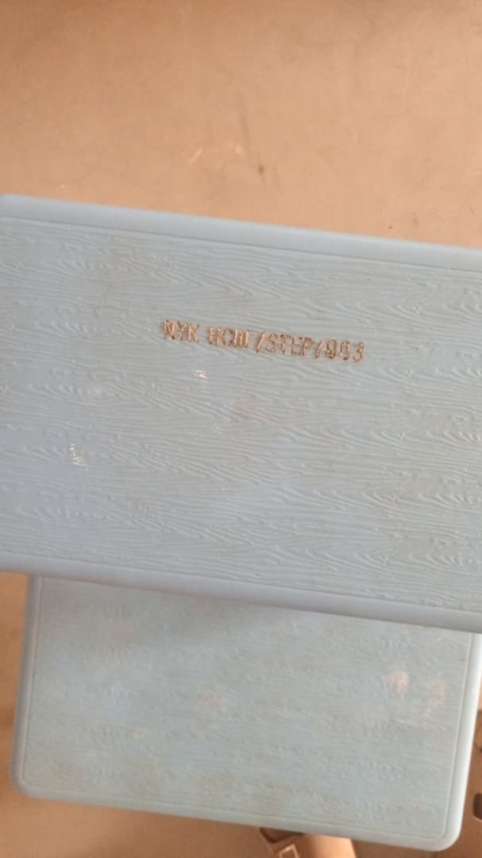

Ladder

